Spring - MVC Framework

The Spring Web MVC framework provides Model-View-Controller (MVC) architecture and ready components that can be used to develop flexible and loosely coupled web applications

The MVC pattern results in separating the different aspects of the application (input logic, business logic, and UI logic), while providing a loose coupling between these elements.

- The Model encapsulates the application data and in general they will consist of POJO.

- The View is responsible for rendering the model data and in general it generates HTML output that the client's browser can interpret.

- The Controller is responsible for processing user requests and building an appropriate model and passes it to the view for rendering.

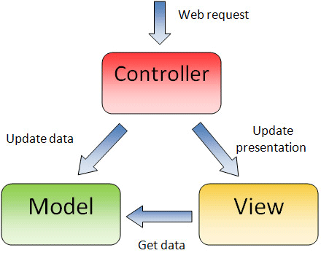

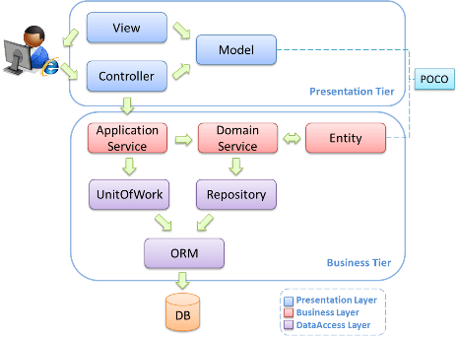

DispatcherServlet

The Spring Web model-view-controller (MVC) framework is designed around a DispatcherServlet that handles all the HTTP requests and responses.

The request processing workflow of the Spring Web MVC DispatcherServlet is illustrated in the following diagram −

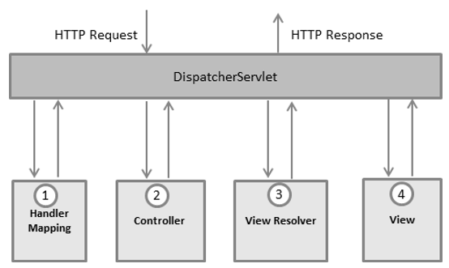

- After receiving an HTTP request, DispatcherServlet consults the HandlerMapping to call the appropriate Controller.
- The Controller takes the request and calls the appropriate service methods based on used GET or POST method. The service method will set model data based on defined business logic and returns view name to the DispatcherServlet.
- The DispatcherServlet will take help from ViewResolver to pickup the defined view for the request.
- Once view is finalized, The DispatcherServlet passes the model data to the view which is finally rendered on the browser.

Dispatcher Servlet (Spring Controller)

- When a web request is sent to a Spring MVC application, dispatcher servlet first receives the request
- Then it organizes the different components configured in Spring’s web application context (e.g. actual request handler controller and view resolvers) or annotations present in the controller itself, all needed to handle the request.

- To define a controller class in Spring 3.0, a class has to be marked with the @Controller annotation.
- To define a controller class in Spring 3.0, a class has to be marked with the @Controller annotation.
- This requires that a controller class map each request to a handler method by one or more handler mappings. In order to do so, a controller class’s methods are decorated with the @RequestMapping annotation, making them handler methods.
- After a handler method has finished processing the request, it delegates control to a view, which is represented as handler method’s return value.
- To resolve the correct file for a logical name is the responsibility of view resolvers. Once the controller class has resolved a view name into a view implementation, per the view implementation’s design, it renders the objects.

Spring DispatcherServlet – how it works?

1. What is Spring DispatcherServlet
- DispatcherServlet acts as front controller(software design pattern) for Spring based web applications
- It provides a mechanism for request processing where actual work is performed by configurable, delegate components.
- It is inherited from javax.servlet.http.HttpServlet, it is typically configured in the web.xml file.
- A web application can define any number of DispatcherServlet instances.
- Each servlet will operate in its own namespace, loading its own application context with mappings, handlers, etc
- Only the root application context as loaded by ContextLoaderListener, if any, will be shared
- In most cases, applications have only single DispatcherServlet with the context-root URL(/)
- DispatcherServlet uses Spring configuration classes to discover the delegate components it needs for request mapping, view resolution, exception handling etc.

2. How it uses WebApplicationContext
Let’s understand how dispatcher servlet works internally?
- In a Spring-based application, our application objects live within an object container.
- This container creates objects and associations between objects, and manages their complete life cycle
- WebApplicationContext is an extension of a plain
- it is web aware ApplicationContext i.e it has Servlet Context information.
- When DispatcherServlet is loaded, it looks for the bean configuration file of WebApplicationContext and initializes it.

3. DispatcherServlet XML Configuration
<web-app>

<listener>
<listener-class>org.springframework.web.context.ContextLoaderListener</listener-class>
</listener>

<context-param>
<param-name>contextConfigLocation</param-name>
<param-value>/WEB-INF/dispatcher-servlet-context.xml</param-value>
</context-param>

<servlet>
<servlet-name>dispatcher-servlet</servlet-name>
<servlet-class>org.springframework.web.servlet.DispatcherServlet</servlet-class>
<init-param>
<param-name>contextConfigLocation</param-name>
<param-value></param-value>
</init-param>
<load-on-startup>1</load-on-startup>
</servlet>

<servlet-mapping>
<servlet-name>dispatcher-servlet</servlet-name>
<url-pattern>/*</url-pattern>
</servlet-mapping>

</web-app>

In above code, dispatcher-servlet-context.xml file will contain all beans definitions and associations which will be available to DispatcherServlet. These bean definitions will override the definitions of any beans defined with the same name in the global scope. e.g.

<beans xmlns="http://www.springframework.org/schema/beans"
xmlns:xsi="http://www.w3.org/2001/XMLSchema-instance"
xsi:schemaLocation="http://www.springframework.org/schema/beans
http://www.springframework.org/schema/beans/spring-beans-2.5.xsd">

<bean id="viewResolver"
class="org.springframework.web.servlet.view.InternalResourceViewResolver" >
<property name="prefix">
<value>/WEB-INF/views/</value>
</property>
<property name="suffix">
<value>.jsp</value>
</property>
</bean>

</beans>

4. DispatcherServlet Java Configuration
Starting from Servlet 3.0, in addition to declarative configuration in the web.xml file, DispatcherServlet can be configured programmatically by implementing or extending either of these three support classes provided by Spring –
- WebAppInitializer interface
- AbstractDispatcherServletInitializer abstract class
- AbstractAnnotationConfigDispatcherServletInitializer abstract class

4.1. WebAppInitializer Example
In below class, WebApplicationInitializer ensures that class ApplicationInitializer is detected by SpringServletContainerInitializer (which itself is bootstrapped automatically) and used to initialize any Servlet 3 container.

public class ApplicationInitializer implements WebApplicationInitializer
{
@Override
public void onStartup(ServletContext servletContext) throws ServletException
{
XmlWebApplicationContext appContext = new XmlWebApplicationContext();
appContext.setConfigLocation("/WEB-INF/dispatcher-servlet-context.xml");

ServletRegistration.Dynamic registration = servletContext
.addServlet("rootDispatcher", new DispatcherServlet(appContext));
registration.setLoadOnStartup(1);
registration.addMapping("/");
}
}

4.3. AbstractDispatcherServletInitializer Example

BEAN | RESPONSIBILITIES
HandlerMapping | Maps incoming web requests to handlers and pre- and post-processors
HandlerAdapter | Invokes the handler which resolves arguments and dependencies, such as annotated arguments for URL-mapped controller method endpoints
HandlerExceptionResolver | Allows programmatic handling of exceptions and maps exceptions to views
ViewResolver | Resolves logical view names to view instances
LocaleResolver | Resolves the client’s locale in order to enable internationalization
LocaleContextResolver | A richer extension of LocaleResolver, with timezone information
ThemeResolver | Resolves themes configured in your app for enhanced user experience
MultipartResolver | Handles multipart file uploads as part of HTTP requests
FlashMapManager | Manages FlashMap instances that store temporary Flash attributes between requests redirected from one another

